**LAB PROGRAM**

**Write a program for congestion control using leaky bucket algorithm**

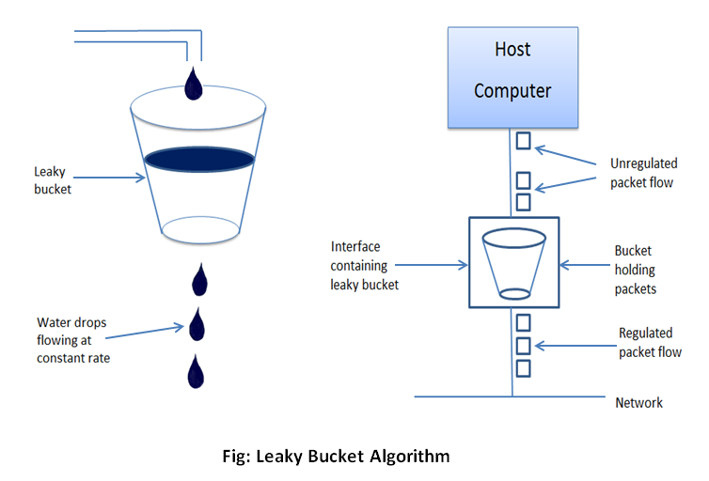

EXAMPLE:

Initially the bucket is empty : remaining =0

Bucket capacity = 4

Rate = 3

|  |  |  |  |  |
| --- | --- | --- | --- | --- |
| I | A[i] | Accepted by bucket | Sent | Remaining |
| 1 | 2 | 2 | 2 | 0 |
| 2 | 4 | 4 | 3 | 1 |
| 3 | 1 | 1 | 2 | 0 |
| 4 | 5 | Dropped | 0 | 0 |
| 5 | 3 | 3 | 3 | 0 |

Code:

import java.util.Scanner;

import java.lang.*;

public class lab7 {

public static void main(String[] args)

{

int i;

int a[]=new int[20];

int buck_rem=0,buck_cap=4,rate=3,sent,recv;

Scanner in = new Scanner(System.in);

System.out.println("Enter the number of packets");

int n = in.nextInt();

System.out.println("Enter the packets");

for(i=1;i<=n;i++)

a[i]= in.nextInt();

System.out.println("Clock \t packet size \t accept \t sent \t remaining");

for(i=1;i<=n;i++)

{

if(a[i]!=0)

{

if(buck_rem+a[i]>buck_cap)

recv=-1;

else

{

recv=a[i];

buck_rem+=a[i];

}

}

else

recv=0;

if(buck_rem!=0)

{

if(buck_rem<rate)

{ sent=buck_rem;

buck_rem=0;

}

else

{

sent=rate;

buck_rem=buck_rem-rate;

}

}

else

sent=0;

if(recv==-1)

System.out.println(+i+ "\t\t" +a[i]+ "\t dropped \t" + sent +"\t" +buck_rem);

else

System.out.println(+i+ "\t\t" +a[i] +"\t\t" +recv +"\t" +sent + "\t" +buck_rem);

}

}

}

Output:

